Student Handout
Wildfire Combustion

Introduction to Wildfires
As you watch the Wildfires 101 YouTube video (tinyurl.com/wildfires101video), answer the following questions:

- How many acres usually burn each year in the United States?
________________________________________________________________

- What are the three components of the fire triangle? Draw the fire triangle.
1. ______________________________________________
2. ______________________________________________
3. ______________________________________________

- What percentage of wildfires are caused by humans?
________________________________________________________________

Part 1: Analyze How Wildfires Have Changed Since the 70s
- Interact with the “California Wildfire History Map” graphic (tinyurl.com/wildfirehistorymap) and follow the instructions in the slide deck (tinyurl.com/wildfireslides).
Write “I notice a pattern…” below and describe what you notice about how the size and number of wildfires in CA have changed in the last 60 years.
- ________________________________________________________________________________________________________________________________________________________________________________________________________________________________________________________________________________________

Part 2: Causes of Wildfires
Analyze the graph. Consider how heat and precipitation impact wildfires in California.
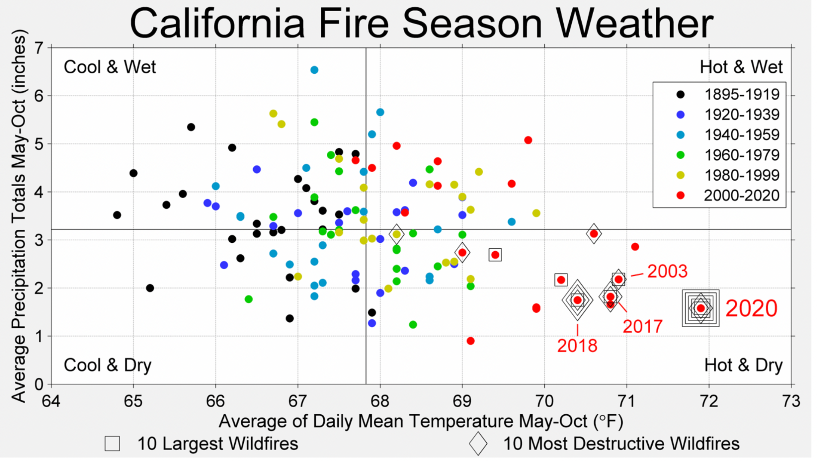
- What patterns can you find in this graph?
________________________________________________________________________________________________________________________________________________________________________________________________________________________________________________________________
- What can you conclude about how heat and precipitation impact wildfires in California?
________________________________________________________________________________________________________________________________________________________________________________________________________________________________________________________________

Wildfire Impact on the Environment

Complete the sentences below as you review the slide deck (tinyurl.com/wildfireslides).
Positive Impact:
- Almost all of California’s diverse ecosystems are ____________or ___________ ______________ ecosystems need wildfire to maintain appropriate function and health, while ______________ ecosystems have evolved to survive wildfire.

- Fire can act as a __________for promoting biological diversity and healthy ____________, reducing the buildup of organic debris, releasing nutrients into the soil, and triggering changes in vegetation community composition.

Negative Impact:

- Wildfires impact on community health: One of the pollutants found in wildfire smoke is ______________. These particles are so small that they enter and lodge deep in the ______, and trigger _____________, heart attacks and strokes.

- The costs associated with wildfires include those incurred __________ and __________ the fire. Direct costs include damages to private properties, damages to local infrastructure such as utility lines, loss of timber resources, and aid for evacuated communities

- Wildfires affect the Earth’s climate. Forests in particular store large amounts of carbon. When they burn, they immediately release ______________ into the atmosphere, which in turn contributes to climate change. After burning, ___________ also release carbon dioxide more gradually through _______________.

Combustion: The Chemical Reaction of Fire

As you watch the What is Combustion? YouTube video (tinyurl.com/combustionvideo), answer the following questions:

7. What is a chemical reaction?
________________________________________________________________________________________________________________________________
________________________________________________________________

8. What is needed for a combustion reaction to happen?
________________________________________________________________________________________________________________________________
________________________________________________________________

9. What does a combustion reaction produce?
________________________________________________________________________________________________________________________________
________________________________________________________________

Climate Change and Wildfires
Wildfire Article Jigsaw
Instructions:
- Jigsaw Group A (informing)
- In group A, each person will read one different article.
- Read your assigned article. Take notes in the table below just for your article.

- Jigsaw Group B (diving deeper)
- Group B is formed with the people who have read the same article.
- Discuss the article with the people who read your same article and make a slide presentation on your article.

- Back to your Group A (teaching to others)
- Each group member will present their article to the other groupmates using the slides for support.
- As one member explains the article, the others complete the Jigsaw notes in the table.

Jigsaw Notes:
Article | What claims are made in the article? | What evidence supports these claims?
1. How Wildfires Can Affect Climate Change (and Vice Versa)
tinyurl.com/wildfirearticle1
2. Frequently Asked Questions: Wildfire Emissions. Fire is part of Earth’s carbon cycle; combustion of fossil fuels is not.
tinyurl.com/wildfirearticle2
3. Wildfire climate connection
tinyurl.com/wildfirearticle3

Reflection Questions: What did you learn from these articles that surprised you?

__________________________________________________________________________________________________________________________________________________________________________________________________________________________________________________________________________________________________________________________________________________________________________________________________________________________________________________________________________________________________________

How Wildfires Affect Our Community

Overview
- CO₂ is one of the products of the combustion reaction and is therefore a product of wildfires.

- According to California’s Air Resources Board (CARB), the 2020 wildfire GHG emissions were the worst fire year on record (by acres burned) for the State of California. The emissions estimate, 112 million metric tons of CO₂, is equivalent to the amount of carbon contained in the structural lumber of 6.3 million average California homes, or over 75 percent of all homes in California.

- Carbon dioxide emissions from boreal forest fires have been increasing since at least the year 2000, reaching a new high in 2021, Zheng et al. report. Although boreal fires typically produce about 10% of global carbon dioxide emissions from wildfires, in 2021 they produced nearly one-quarter of the total.

Part 1: Analyze Local Urban Air Quality Data
Introduction of BEACO₂N sensors

- After watching the YouTube video Ron Cohen on "BEACO2N" Climate Change Sensors (tinyurl.com/cohenonbeacon), summarize what you have learned about BEACO₂N.
__________________________________________________________________________________________________________________________________________________________________________________________________________________________________________________________________________________________________________________________________________________________________________________________________________________________________________________________________________________________________________
______________________________________________________________________________________________________________________________________________________________________________________________________________________________________________________________________________________________________________________________________________________________

How can we analyze data from BEACO₂N nodes?

The BEACO₂N sensors measure CO₂ concentrations and other greenhouse gases. The data are collected once every five seconds onto a miniature computer which then sends the data to a centralized server. This data is saved as a '.csv' file (Comma Separated Values). CSV files can be easily read and written by many software tools, including spreadsheet applications like Microsoft Excel, Google Sheets, or Python libraries like Pandas, which we use in coding. CSV are used in data science because they are a lightweight, easy-to-use format for storing and sharing large amounts of data.
In order to analyze the CSV files produced by BEACO₂N sensors we are going to introduce and use Jupyter Notebooks (and a coding language called Python). Yes, we are going to code!

Part 2: Application of Data Analysis
Showcase of BEACO₂N sensors: Orange Sky Over the Bay Area

On Wednesday, September 9th, 2020, Bay Area residents woke up to an orange sky and general haze that lasted throughout the day. These conditions were caused by record-setting wildfires burning across the states of California, Colorado, Oregon, and Washington. The fires resulted in thick particle clouds that scattered blue wavelengths of light and left only reds and yellows, creating this odd red haze.
While visibility was affected on September 9th, it wasn't until the following day (Thursday, September 10th) that the air quality became dramatically worse, a trend that continued for over a week afterward. This poor air quality was recorded by several nodes in the BEACO₂N network.

If you haven’t already, open your IN CLASS: Wildfire Combustion notebook.

After completing the In Class notebook, summarize what you learned about CO₂ and PM2.5 concentrations during wildfire periods.

______________________________________________________________________________________________________________________________________________________________________________________________________________________________________________________________________________________________________________________________________________________________

If you haven’t already, open your EXPLORATION: Wildfire Combustion notebook.
Work through Sections 1 and 2 of the notebook.

When you reach Section 3, follow these instructions:
Group Project using BEACO2N data:
- We will separate the class into three groups, each studying a specific pollutant: CO₂, NOx, or PM (particulate matter).
- Each group will explore that pollutant during a wildfire period using BEACO₂N data. Complete section 3.1 in the notebook to load your corresponding data. Complete section 3.2 about Data Visualization and analysis.
- Answer Q3 and Q4 in section 3.2 of the notebook. This requires collaborating with another group. This section helps you brainstorm for the last part of this project!
- Finally, each group will do a presentation showing their findings!
  - Format options:
    - Poster
    - Slide deck with voice-over
  - Presentation duration: 5 minutes maximum
  - Requirements to include:
    - Research about how wildfires affect your pollutant.
    - The results of your data analysis in your notebooks and an explanation of them. Include your plot and a table of summary statistics (use .describe() on your DataFrame like we did in the In Class Notebook)
    - A conclusion that links your data analysis with your research findings.

